

Real Life

Life Changing

Changing Healthcare

User Guide

November 2019



­­­



Real Life

Life Changing

Changing Healthcare

User Guide

December 2019



Copyright

NAVVIS Unified Ecosystem Experience (UEE) user guide release 1.00.

Copyright © 2019 NAVVIS & Company, LLC. All rights reserved.

Trademarks

The other product names mentioned may be trademarks of their respective owners.

Disclaimer

Sample names and persons used in this document are purely fictitious and do not refer to real names or persons.

This user's guide has been created with utmost care; nevertheless, it is not guaranteed that this document is error free.

No part of this document may be reproduced or transmitted in any form or by any means, electronic or mechanical, for any purpose, without the express written approval of Navvis & Company.

Table of Contents

1 Preface 5

1.1 About Navvis Coreo Unified Ecosystem Experience 5

1.2 Purpose of this document 5

1.3 Intended audience 5

1.4 Organization of the document 6

1.5 Document Conventions 6

1.6 Browsers Versions for UEE 6

Unified Ecosystem Experience User Function 7

1 User onboarding 8

1.1 Log into UEE—first time user 8

1.2 Manage locked NAVVIS-Okta SSO account 12

1.3 Reset a forgotten or expired password 13

2 UEE screen layout—panel view 14

2.1 Toolbar elements 15

2.2 Panel elements 16

3 Display settings for UEE panel view 17

3.1 Display Settings window—layout and navigation 17

4 Creating presets for single panel format 17

4.1 Create presets for single panel view 17

4.2 Apply a single panel preset 17

4.3 Pin a single panel preset to the toolbar 17

5 Creating presets for multi-panel format 17

5.1 Create presets for double panel view 17

5.2 Apply a double panel preset 17

5.3 Pin a double panel preset to the toolbar 17

5.4 Save and apply a double panel preset 17

5.5 Create presets for triple-panel view 17

5.6 Apply a triple panel preset 17

5.7 Pin a triple panel preset to the toolbar 17

5.8 Save and apply a triple panel preset 17

6 Editing the toolbar 18

6.1 Pin a Coreo application to the toolbar 18

6.2 Apply a Coreo application to the screen 18

7 Panel formats and screen resolutions 18

7.1 Panel formats in standard view and widescreen view 18

7.2 Screen resolutions for optimal display of pinned applications 18

8 Viewing synchronized patient records 19

8.1 Synchronize patient records across applications in panel view 19

9 Appendices 20

10 Glossary 21

11 Index 22

# Preface

Welcome to the release of the NAVVIS Unified Ecosystem Experience user guide.

## About Navvis Coreo Unified Ecosystem Experience

Navvis Coreo UEE application supports the display of other Coreo ecosystem applications such as Coreo View, Coreo Home, and Coreo Analytics in a single panel view, for standard screens and widescreens, and in multi-panel view for widescreens.

UEE allows its users to configure a Coreo application to view it in a single panel or configure multiple Coreo applications to view them in multiple panels on their device screen, with each application assigned to a panel.

Navvis & Company provides counsel to health systems, hospitals and physician groups on the development of innovative, market-linked strategies to build future-ready health systems, cultivate tomorrow’s leaders and strengthen strategic performance.

## Purpose of this document

This guide is the primary source of information about Navvis Unified Ecosystem Experience. It contains overviews, processes, and procedure to use the Unified Ecosystem Experience application effectively.

## Intended audience

1. The regular users of the Unified Ecosystem Experience application who include the following personnel:

* Clinical staff and hospital administrators
* Employees, consultants, contractors or agents of the clinicians or patients who have been invited by the clinician or patient to access and use the service to participate in the care of the patient.
* Any other person or entity involved in the care of the patient including patient's care providers, patient's insurer or payer, or a social worker, or government agencies.

1. Unified Ecosystem Experience administrator users who are assigned the task of managing the regular users of the Unified Ecosystem Experience application

## Organization of the document

This document contains the following modules:

* Module 1, “User onboarding”
* Module 2, “UEE panel view—Screen layout and navigation”
* Module 3, “Display settings for UEE panel view”
* Module 4, “Creating presets for single panel format”
* Module 5, “Creating presets for multi-panel format”
* Module 6, “Editing the toolbar”
* Module 7, “Panel formats and screen resolutions”
* Module 8, “Synchronizing patient records”

## Document Conventions

This document uses the following conventions:

| Convention | Item |
| --- | --- |
| **boldface** font | **Menu** items, **Tab** names, **Text** **box** names, **List** **box** names, **Button** names and **Navigation** paths |
| Text in blue | Hyperlinks |
|  | Note: Notes contain helpful suggestions. A note will inform the reader about any deviation in the sequence of instructions or helps the reader save time in understanding why something is not working. |
|  | Tip: The information will help the user solve a problem faster, or to perform an action in a different way. |
|  | Caution alerts the reader to avoid doing something that could result in loss of data or any other damage. |

## Browsers Versions for UEE

The Unified Ecosystem Experience application is available on desktops, laptops, and IOS devices for standard screens and widescreens.

| Browser | Version |
| --- | --- |
| Google Chrome | 74 |
| MS Internet Explorer | 11 |
| Macbook - Safari | 12 |

Unified Ecosystem Experience User Function

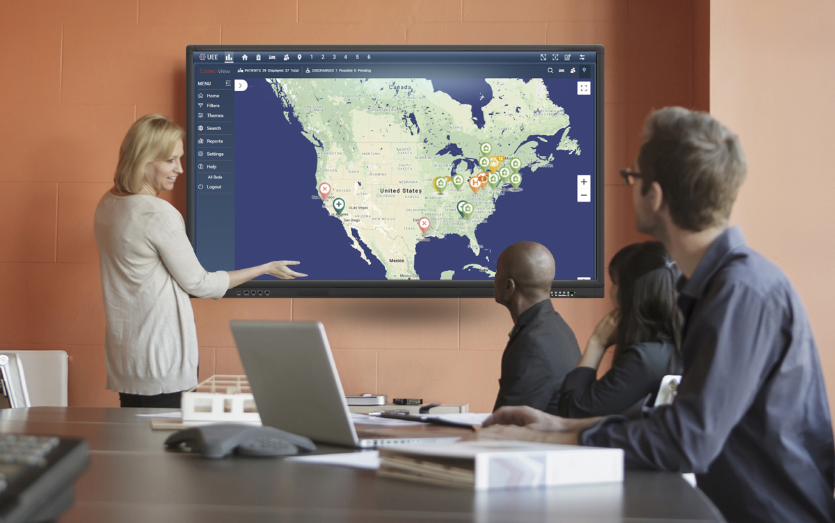

# User onboarding

A first-time user of Unified Ecosystem Experience (UEE) receives an automated email verification link from the Okta system administrator to activate the Okta account. Okta Single Sign-On(SSO) provides a single secure home page to use the UEE application.

## Log into UEE—first time user

Follow these steps to activate the Navvis-Okta SSO account to access the Unified Ecosystem Experience application:

1. Open the email link sent to your email inbox by the Okta administrator.



1. Email Notification
2. Select the ActivateAccLinkGreenBox.png link. The **Create your Navvis account** screen opens.

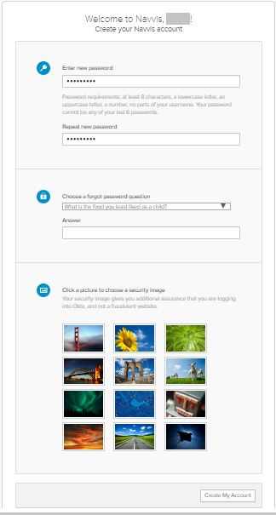

1. Create Your Navvis Account Screen
2. Enter the new password in **Enter new password**. The password must be at least 8 characters long and a maximum of 25 characters.

The password must be a combination of these following characters:

| Description | Characters |
| --- | --- |
| Upper case characters | A – Z |
| Lower case characters | a – z |
| Digits | 0 – 9 |
| Special characters | ~ ! @ # $ % ^ & * _ - + = ` | \ () {} [] : ; " ' < > , . ? / |

1. System Accepted Password Characters
2. Reenter the password in the **Repeat new password** box.
3. The user must add a security question to reset a new password in the scenario where user may forget the password during the future use.
4. Under **Choose a forgot password** question, select the arrow to view the questions.



1. Choose A Forgot Password Question
2. Choose a security question from the list.
3. In the **Answer** box, enter the answer. You must remember this answer because it is used at a later date to reset a forgotten or expired password.
4. Choose a picture as a security image in the **Create your Navvis account** screen and then select **Create My Account**.

|  |  |
| --- | --- |
|  | The security image displays in the NAVVIS Sign In screen on entering the user name. |

1. The **Navvis** landing screen opens.

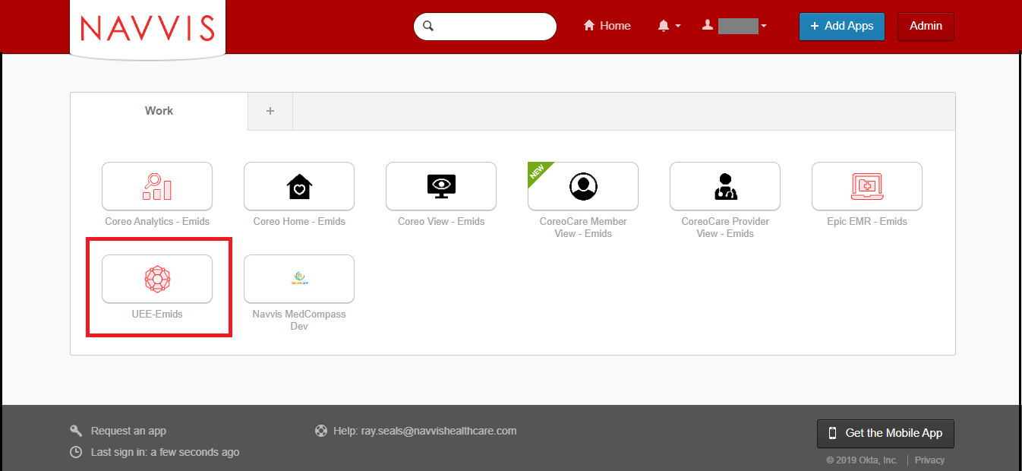

1. NAVVIS Landing Screen
2. Select the **UEE - Emids** button on the landing screen.
3. The **NAVVIS Sign in** screen opens.

|  |  |
| --- | --- |
|  | Once the user accepts EULA and the Navvis-Okta SSO account is activated, the new user becomes an existing user.  As an existing user, go to [navvis.oktapreview.com](https://navvis.oktapreview.com/) to open the NAVVIS Sign in screen. |



1. NAVVIS Sign In Screen
2. Enter the user ID in the **Username** box.
3. Enter the password in the **Password** box. The password must be at least 8 characters long and a maximum of 25 characters.
4. Select **Sign In**.
5. The EULA screen displays for a first-time user of UEE. A first-time user of UEE is required to accept the EULA (End User License and Business Associate Agreement) before accessing the UEE application.

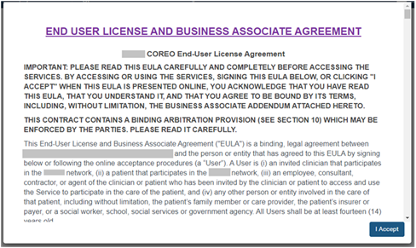

1. EULA PAGE
2. Read the terms and conditions and select the **I Accept** button. Your NAVVIS account is activated successfully and the UEE home page opens.

## Manage locked NAVVIS-Okta SSO account

The Navvis-Okta SSO account locks for the following reasons:

* The user exceeds five failed login attempts within 24 hours. The login attempts fail when the user enters an incorrect password.

The locked account resets after 24 hours and the user can log in to the account after 24 hours without contacting the Okta system administrator.

|  |  |
| --- | --- |
|  | To unlock the NAVVIS account immediately after the five failed login attempts, contact the Okta system administrator. |

* The Okta system administrator can lock the NAVVIS-Okta SSO account as per the company lock account policy.

## Reset a forgotten or expired password

The Okta Single Sign-On password policy specifies that the password expires after 60 days, and the user must reset the password periodically.

Also, if the user forgets the password, Navvis-Okta gives the option to reset the password.

Follow these steps to reset the password:

1. Go to [navvis.oktapreview.com](https://navvis.oktapreview.com/) to open the **Navvis Sign in** screen.



1. NAVVIS Sign In Screen - Forgot password? Option
2. Select the **Need help signing in?** drop-down list.
3. Select the **Forgot password?** option to open the **Reset Password** screen.



1. Reset Password Screen
2. Enter the e-mail or the user name in the **Email or Username** box.
3. Select **Reset via E-mail**. The user can reset the password using the verification link sent to the user’s email address.
4. Reset the password with the following considerations:

* The new password cannot be among the previous six passwords.
* The password expires after 60 days and the user must reset the password periodically.
* The user will be locked out of the application after five failed login attempts. The login attempts fail when the user enters an incorrect password. Contact the Okta administrator to reset the password.

On the successful resetting of the password, the new password is reset for the Navvis-Okta Single Sign-On account.

# UEE screen layout—panel view

The screen layouts in the UEE application are similar in appearance. However, a few user interface elements differ depending upon the following reasons:

* The number (one, two or three) of panels that are displayed on the screen
* The type of user login — a first time user of UEE or an existing user
* The user’s role and permissions

The user can configure a Coreo application to view it in a single panel or configure multiple Coreo applications to view them in multiple panels on their device screen, with each application assigned to a panel.

Each of this configuration that assigns the Coreo applications to their panels and which can be applied to the device screen layout is called a preset.

The single panel configuration is available on standard screens and widescreens, and the multi-panel configurations are available on widescreen only.

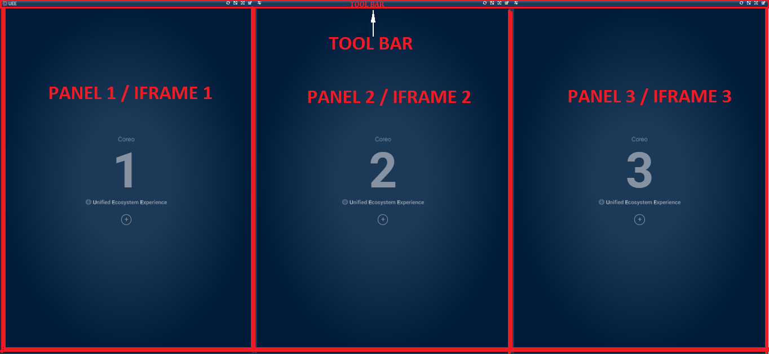

1. UEE Home Page

The UEE home page layout includes the following areas:

* Toolbar: Includes buttons to apply the presets to the panels, to access the display settings for the panel, and to control the magnification settings of the panel screen.
* Panel or Iframe: Each Coreo application can be assigned to a panel and can have a maximum of three panel views.

The user can assign the following Coreo applications to a panel at a time:

* + Coreo Analytics
  + Coreo Home
  + Coreo View
  + Coreo Care - Member View
  + Coreo Care – Provider View
  + Epic EMR
  + Navvis MedCompass Dev

Toolbar elements

The toolbar runs across all the three panels on the UEE screen. The **Refresh** button, the **Maximize Display** button, the **Help** button, and the **Display** **Settings** button are available for each panel and are located in the upper-right corner of the panel on the toolbar.

The **Swap** button is located in the upper-left corner of the second panel and third panel on the tool bar.

Refer to the following table to view details about the elements on the tool bar.

| Icon | Element name | Description |
| --- | --- | --- |
|  | **UEE** Logo | The UEE logo |
|  | **Refresh** button | Use this to refresh the Coreo application of that panel. |
|  | **Maximize Display** toggle button | Use this button to enlarge the panel layout view to fit the entire screen of the device. Select the same button or select **Esc** on the keyboardto exit the full screen. |
|  | **UEE Help** button | Use this button to open the UEE user help document. |
|  | **Display Settings** button | Use this button to open the **Display Settings** pop-up window. In the pop-up window, you can create, modify, or delete presets. You can also pin a Coreo application or a preset to the tool bar using this window. |

1. Toolbar Elements

## Panel elements

Refer to the following table to view details about the elements in the panel.

| Icon | Element name | Description |
| --- | --- | --- |
|  | First panel / First iframe | Panel number one. The UEE screen can display a maximum of three panels. The first panel is the Left (**L**) panel. |
|  | Second panel / Second iframe | Panel number two. The second panel is the Central (**C**) panel. |
|  | Third panel / Third iframe | Panel number three. The third panel is the Right (**R**) panel. |
|  | **Display Settings** button | Use this button to open the **Display Settings** pop-up window. You can click anywhere in the panel area to open the **Display** **Settings** window . |
|  | UEE logo | The UEE logo |

# Display settings for UEE panel view

## Display Settings window—layout and navigation

# Creating presets for single panel format

## Create presets for single panel view

## Apply a single panel preset

## Pin a single panel preset to the toolbar

# Creating presets for multi-panel format

## Create presets for double panel view

## Apply a double panel preset

## Pin a double panel preset to the toolbar

## Save and apply a double panel preset

## Create presets for triple-panel view

## Apply a triple panel preset

## Pin a triple panel preset to the toolbar

## Save and apply a triple panel preset

# Editing the toolbar

## Pin a Coreo application to the toolbar

## Apply a Coreo application to the screen

# Panel formats and screen resolutions

## Panel formats in standard view and widescreen view

## Screen resolutions for optimal display of pinned applications

# Viewing synchronized patient records

Synchronize patient records across applications in panel view

Appendices

Credits

[www.bloomberg.com/profile/company/3553499Z:US](http://www.bloomberg.com/profile/company/3553499Z:US)

[www.navvishealthcare.com/](http://www.navvishealthcare.com/)

[www.linkedin.com/company/navvishealthcare](http://www.linkedin.com/company/navvishealthcare)

[www.pitchbook.com/profiles/company/88126-75](http://www.pitchbook.com/profiles/company/88126-75)

[www.crunchbase.com/organization/navvis-company](http://www.crunchbase.com/organization/navvis-company)

[www.healthcareitnews.com/blog/defining-population-health](http://www.healthcareitnews.com/blog/defining-population-health)

Glossary

[Glossary term – Description]

[Glossary term – Description]

[Glossary term – Description]

[Glossary term – Description]

[Glossary term – Description]

……………………..

Index

[Depending on the size or complexity of the final document, insert an index to assist the user in locating specific information. Index entries correspond to tags or categories, and are useful in navigating long books.]

[Index term – *page number*]

[Index term – *page number*]

[Index term – *page number*]

[Index term – *page number*]

[Index term – *page number*]